Student Name

Institution Affiliation
Professor Name
Course
Date

Case Study 1
Explain using words and Diagrams the Structure of Carbohydrates
Oxygen, carbon, and hydrogen are the component of carbohydrates. These components are classified as organic compounds arranged in the ketones or aldehydes form with the carbon chain producing several hydroxyl groups. All carbohydrates contain simple sugars as the building blocks, referred to as monosaccharides (Whitford, 2013). Glucose, fructose, and galactose are the only metabolically and nutritionally significant hexoses, as shown in the figure below.
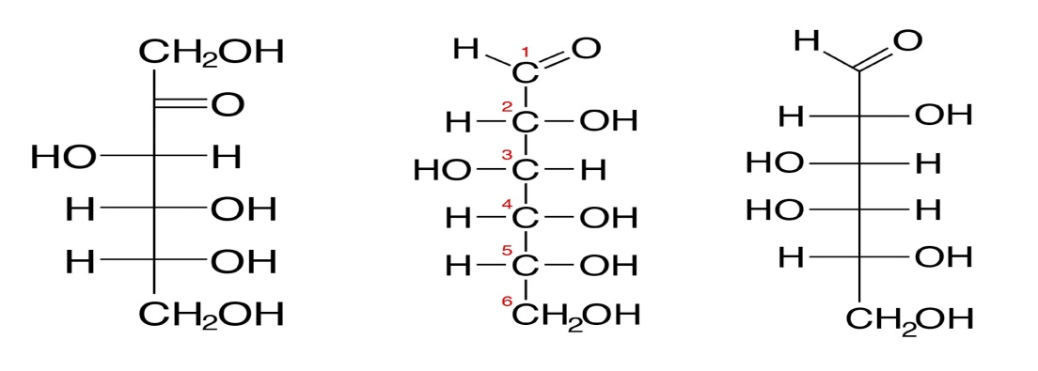
Demonstrate understanding of Monomers and Polymers in Carbohydrates
Monomers in carbohydrates are the smallest unit that will often combine with several other monomers from polymers. In contrast, a polymer is a large molecule formed due to repeating monomers that bond together (Marangoni, Acevedo, Maleky, Peyronel, Mazzanti, Quinn & Pink, 2012). Polymerization is the process through which monomers combine to form polymers.
Explain using words and Diagrams the Structure of Proteins
Proteins are extremely complex substances, and they occur naturally, consisting of residues from the amino acids, which are bonded by the peptide bonds. Proteins are found in all organisms, and they include enzymes, hormones, and antibodies as the compounds that are essentially biological.
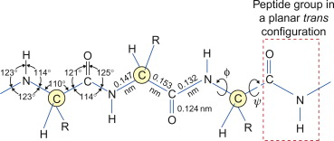
Demonstrate understanding of Monomers and Polymers in Protein
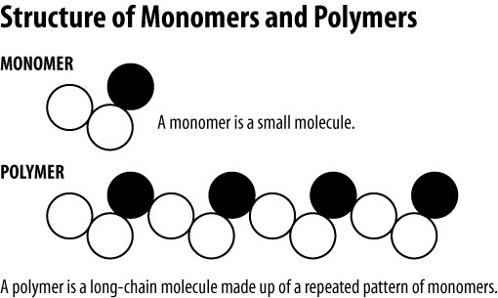
Compare Primary, Secondary, Tertiary and Quaternary Structures of Proteins
The primary structure is the simplest in protein, the amino acid sequence in the polypeptide chain. For instance, insulin in hormones has main two chains of polypeptide. Secondary structures are folded locally, forming around polypeptide due to backbone interactions among atoms. Helix and the pleated sheet are the main types of secondary structures, and their shapes are held by hydrogen bonds forming between the carbonyl of amino H and amino acid. Tertiary structure is the overall polypeptide structure of the three-dimensional. The structure is a result of interactions between amino acids that makes the protein in group R.
Quaternary structure is when subunits combine to produce proteins. Most proteins contain a structure of three levels which are made up of one chain of the polypeptide. Also, other proteins contain many polypeptide chains called subunits.
Explain using words and Diagrams the Structure in Fat
Fatty acids are crucial in microorganisms, animals, and plants as lipids component- soluble fats. Fatty acids have carbon atoms occurring in a straight chain of even numbers, while the hydrogen atoms are within the chain length, and one end of the chain is a group of carboxyl. The following figure shows the structure of the fatty acids.
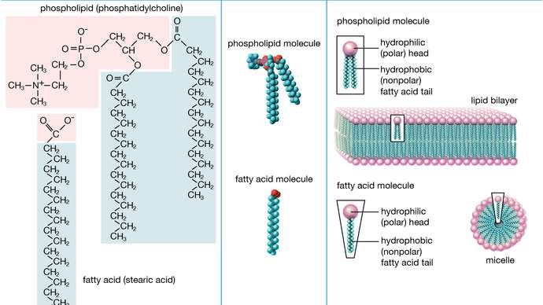
Compare and identify Condensation (Dehydration) and Hydrolysis Reactions.
The main variation between dehydration and hydrolysis is dehydration reaction produces molecules that are large from smaller molecules, while hydrolysis gives out molecules that are smaller from larger molecules. Dehydration leads to the new bond formation, which requires energy (water is removed to bond the molecules), while in hydrolysis, energy is released. Bond broken (in this reaction, water is added for bonds in the molecules to dissolve). However, both are chemical reactions catalyzed by specific enzymes.
Describe the functions of Carbohydrates, Proteins, and Fats in cell and Organisms
Carbohydrates give energy to the cell, which is also known as glucose. Fats produce energy to the organisms and cells after the fatty acids are broken down. Proteins are also used for energy, but they mainly help develop muscle and hormones (Shi, Liu, He, Wang, Chen, Peng & Ma, 2019). All three are used to give energy to organisms and cells after being broken down.
Identify some Functional Groups found in Carbohydrates, Proteins, and Fats.
Every organic molecule contains a functional group that is specific as they play a crucial role in molecule formation. The functional groups in the organic molecules are methyl, amino, carboxyl, sulfhydryl, hydroxyl, phosphate, and carboxyl.
Case Study 2
Explain how Enzymes Work to Speed up Reactions
Enzymes are biological catalysts. Catalysts are used in reactions to reduce the energy used inactivation. When the rate is faster, then it means that the activation energy is lower (Bockisch, 2015). Hence, it concludes that reactions are speed up by enzymes by reducing the energy inactivation.
Explain the Induced Fit Models of how Enzymes Work
An induced-fit model was revealed by Koshland tying to state the binding process in protein conformational changes. The final complex structure will be formed after an enzyme is joined with the substrate, then the interface optimized using the physical interactions. However, enzymes will tend to get to their original states after the reaction is over.
Describe how Enzymes are Regulated (Activated and Inhabited)
Enzymes are regulated by other molecules that will reduce or increase their functions. These molecules that alter the enzyme activity by increase g are referred to as activators, while those that reduce enzyme activity are inhibitors. Types of regulation enzymatic are the covalent modification and genetic, allosteric, and inhibition enzyme (Bockisch, 2015). However, inhibition can only be divided into uncompetitive, non-competitive, and competitive inhibition.
Case Study 3
Explain how Osmosis Works including the Concept of Concentration Gradient

Osmosis works in concern to the water gradient of concentration within the membrane and is proportional to the concentration of the solute. Generally, osmosis happens only when a solute concentration gradient is present within a solution, but solute diffusion is not allowed by the membrane. The concentration gradient affects the osmosis movement in that; faster osmosis of a solvent will only happen when the solute concentration in a solvent is lower (Whitford, 2013). Dark and light will also affect osmosis as the bright light will increase the rate of osmosis.
Compare Passive and Active Transport
In passive transport, no energy is needed for a molecule to move, while in active transport, energy is required for the molecules to move. Also, in passive transport, the molecules tend to move within the gradient of concentration, while in active transport, the movement of molecules is against the gradient of concentration.
Describe the Fluid Mosaic Model of Cell Membrane and how it results in Semi-Permeable Membrane (and what it means)
Most of the consistent experiments apply the model of fluid mosaic to understand the membranes in biology. The model reveals the membrane components like the glycolipids or proteins in constant movements (Gandini & Lacerda, 2015). The movement enables the cell membrane to play its role of acting as a barrier outside and inside the environment of cells.

References
Whitford, D. (2013). Proteins: structure and function. John Wiley & Sons.
Bockisch, M. (Ed.). (2015). Fats and oils handbook (Nahrungsfette und Öle). Elsevier.
Marangoni, A. G., Acevedo, N., Maleky, F., Peyronel, F., Mazzanti, G., Quinn, B., & Pink, D. (2012). Structure and functionality of edible fats. Soft Matter, 8(5), 1275-1300.
Shi, N., Liu, Q., He, X., Wang, G., Chen, N., Peng, J., & Ma, L. (2019). Molecular structure and formation mechanism of hydrochar from hydrothermal carbonization of carbohydrates. Energy & Fuels, 33(10), 9904-9915.
Gandini, A., & Lacerda, T. M. (2015). From monomers to polymers from renewable resources: Recent advances. Progress in Polymer Science, 48, 1-39.

